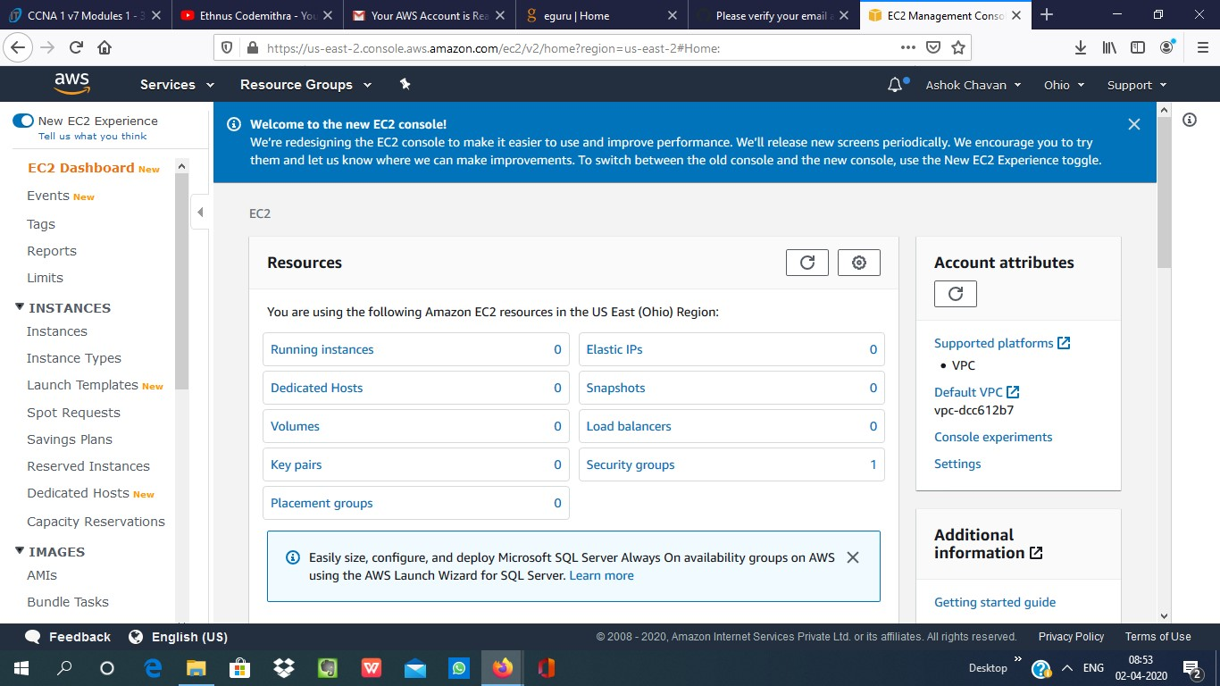**EC2 Dashboard**

1.Choosing an AMI

**2.Choosing an Instance Type**

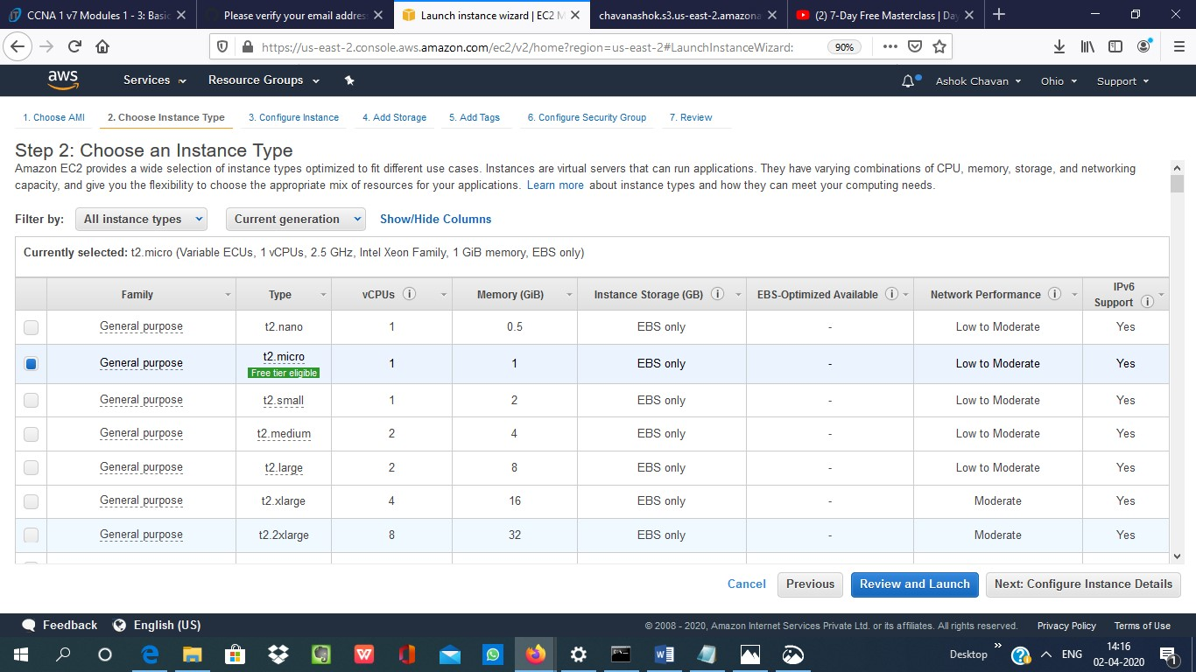

**3.Adding Storage**

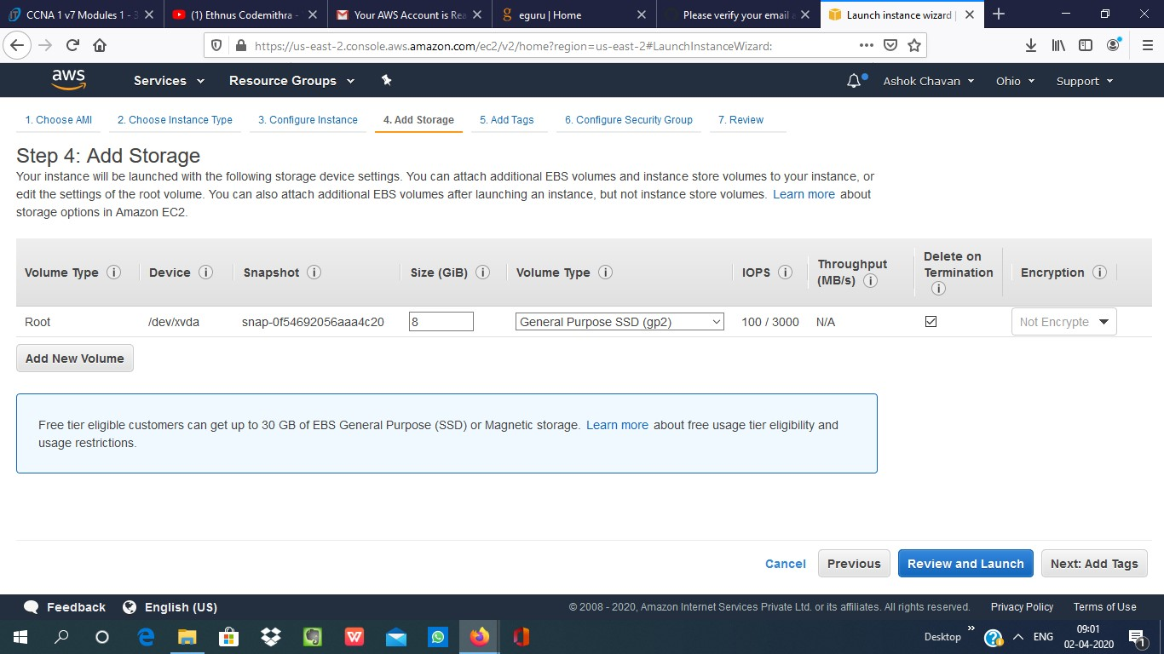

**4. Configuring Security Group**

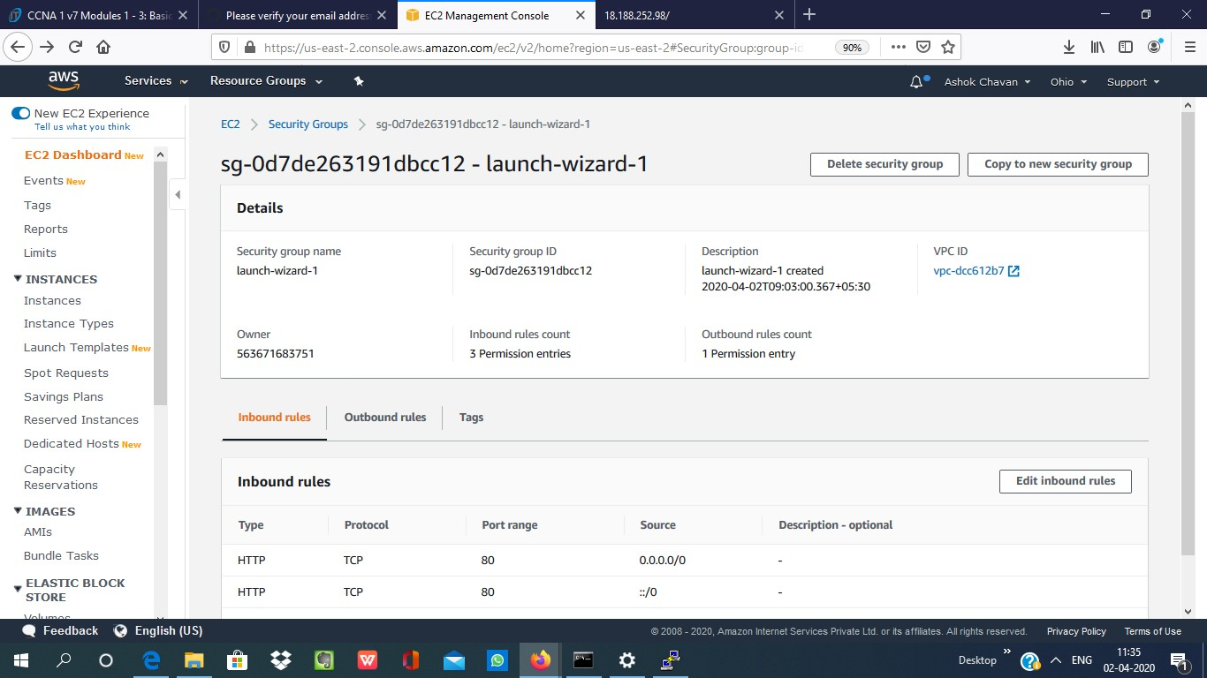

**5.Key Paid Download**

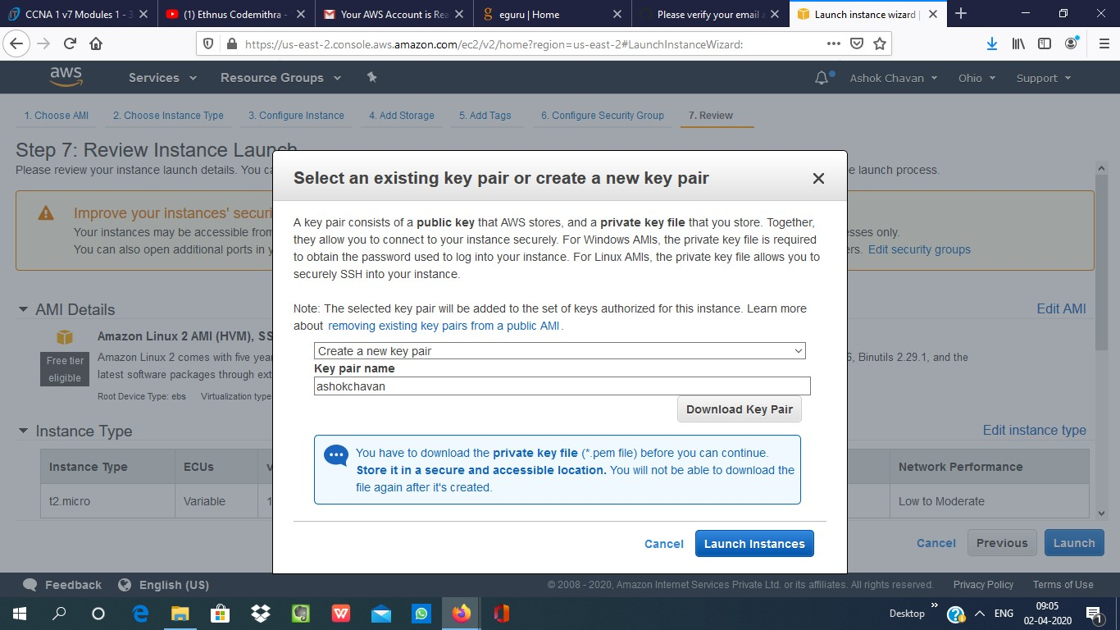

**6.PuTTYgen conversion from pem to ppk**

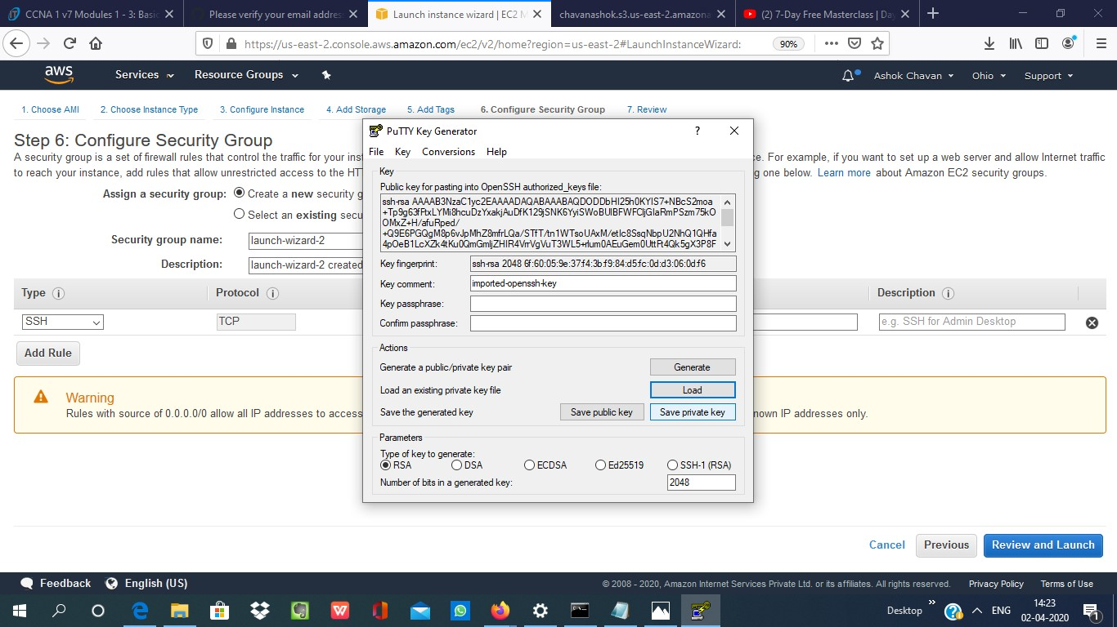

**7. Logged in EC2 black screen**

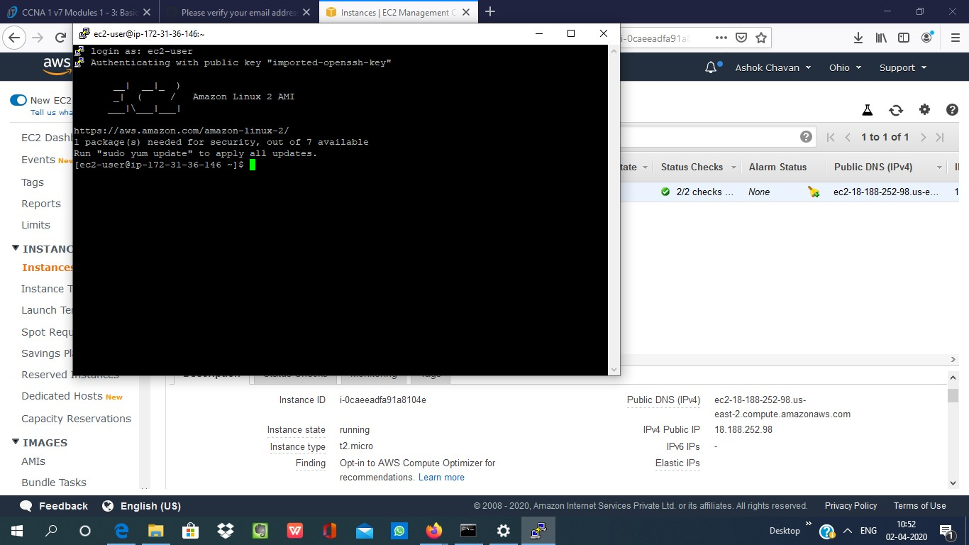

3.S3 Dashboard

**1.Creating a bucket**

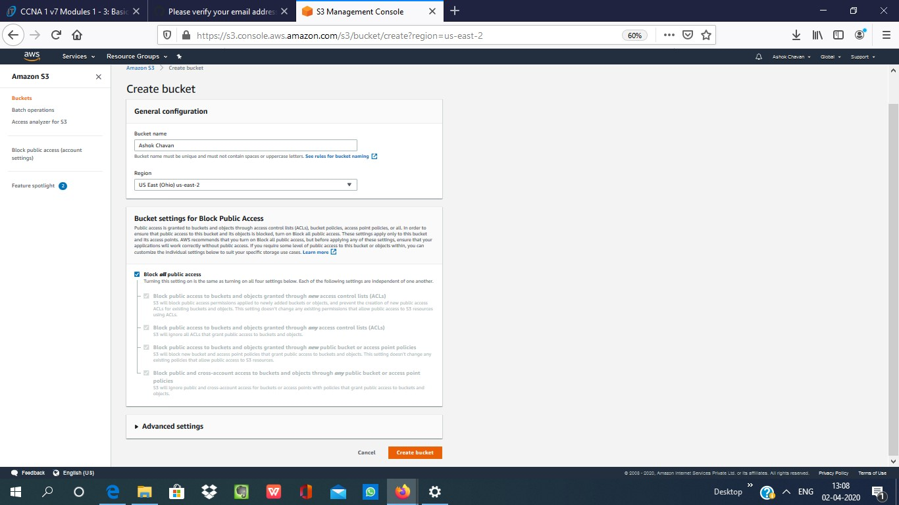

**2.Uploading an Object**

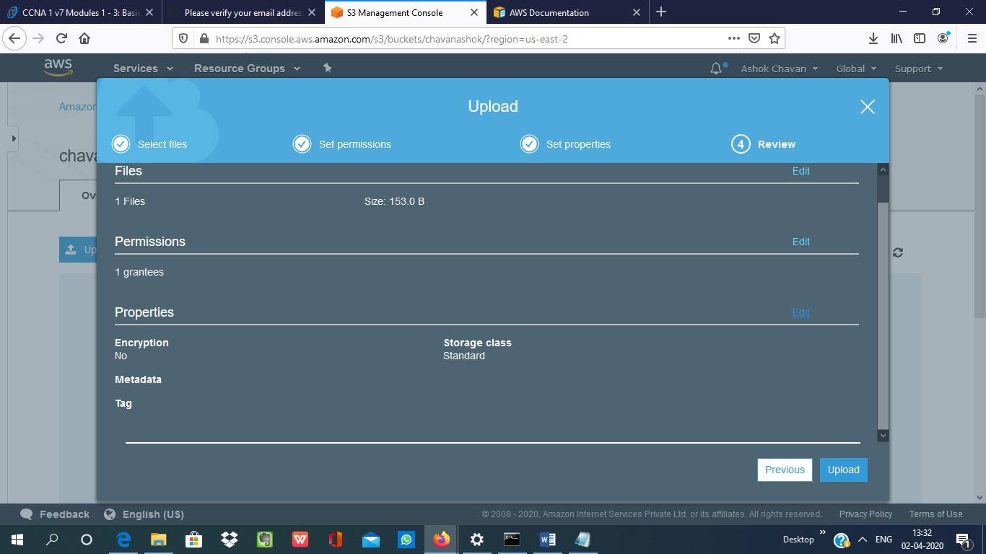

**4.Making the Object Public**

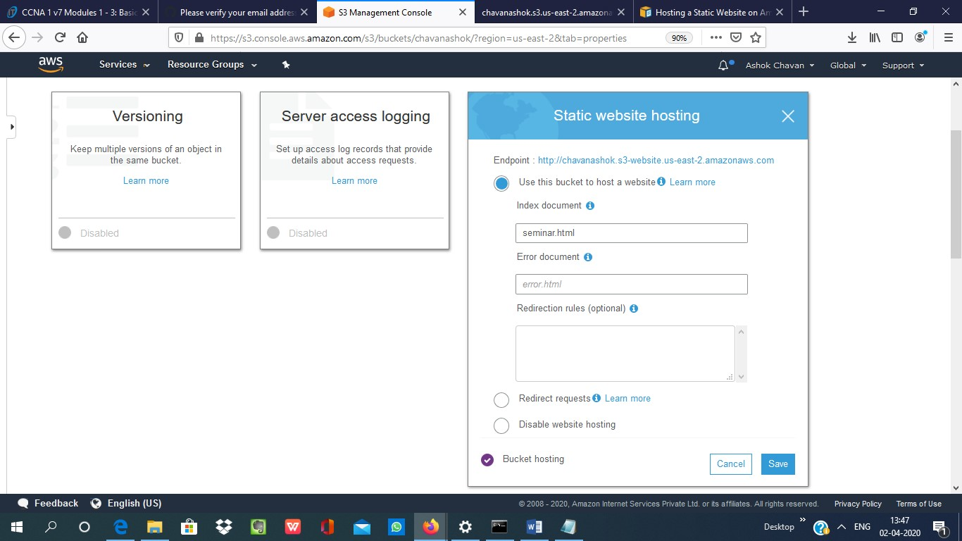

**5.Checking the S3 link on the browser**

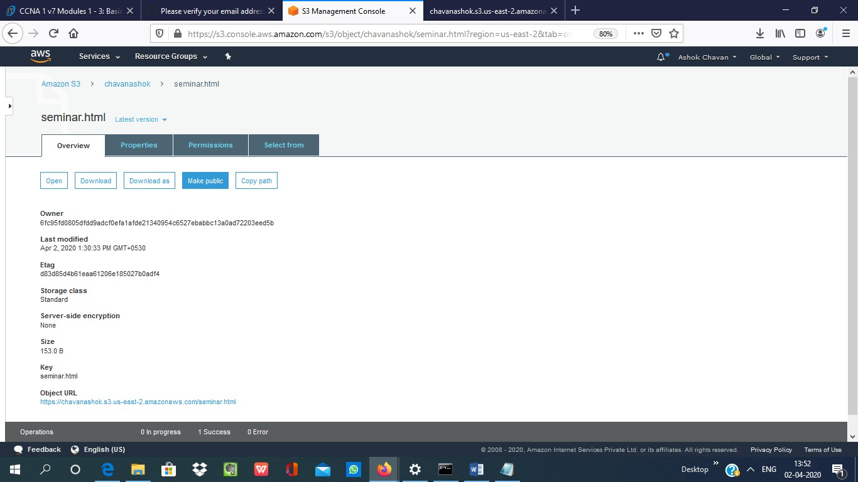

**4.Making the Object Public**

